**Assignment 1: Task 5**

The motive of this task is to copy all the code file that I created according to task 1 to task 4 in my local file and using git command upload it to my git repository  
In this task, I used basically 4 commands.

* Git status – to check status of directory
* Git add – to add file to my repository
* Git commit – to commit the changes
* Git push – Pushing the changes to remote repository

**Action 1: Git Clone – at first cloned my GitHub repository to local gitbash**

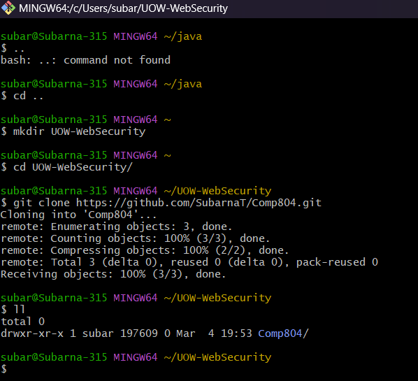

**Action 2: Uploading Task 1 file to local system and pushing to remote git repository**  
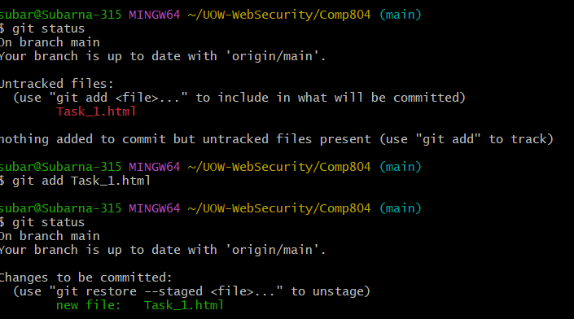

**Action 3 : Uploading task 2 following same step as task 2- Captured screenshot for both git commands and result in Git repository**

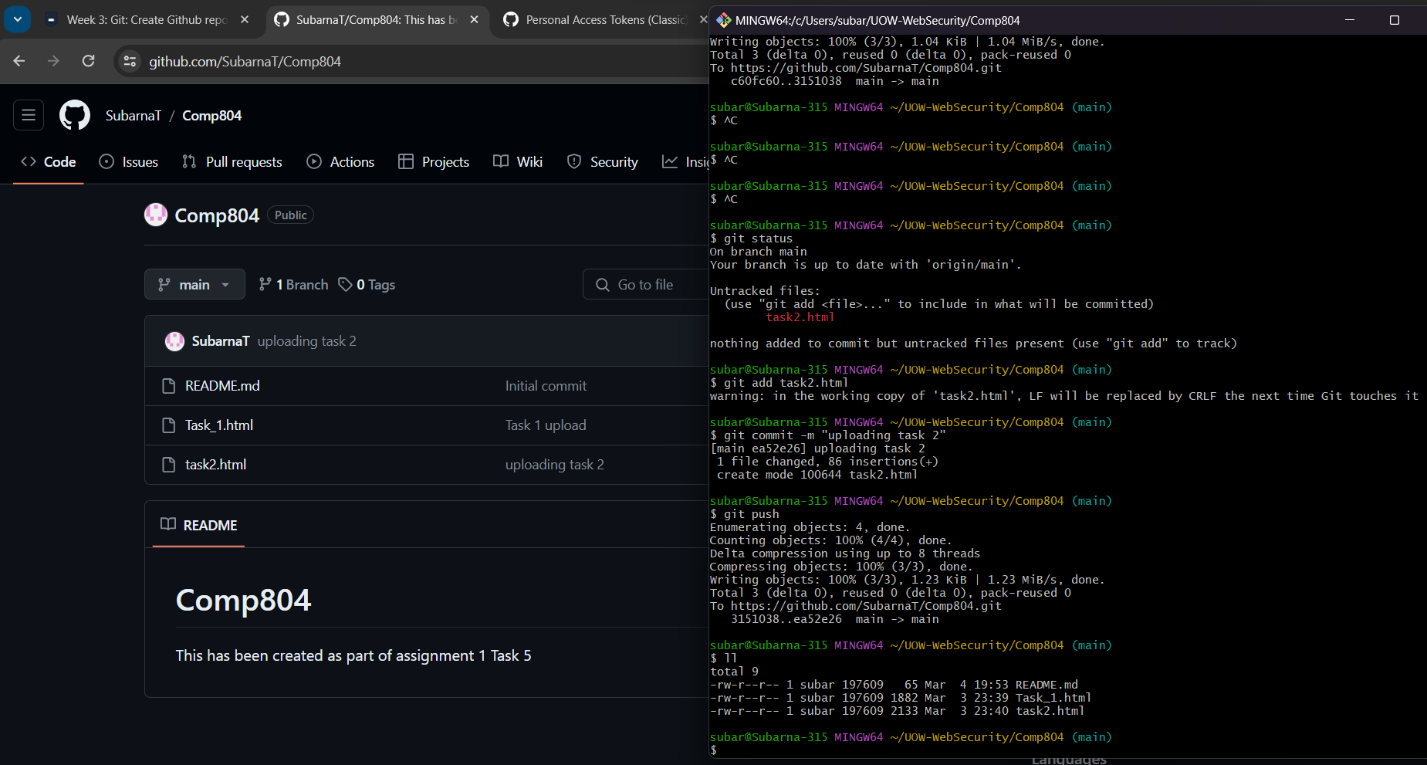

**Action 4: uploading task 3 and task 4**

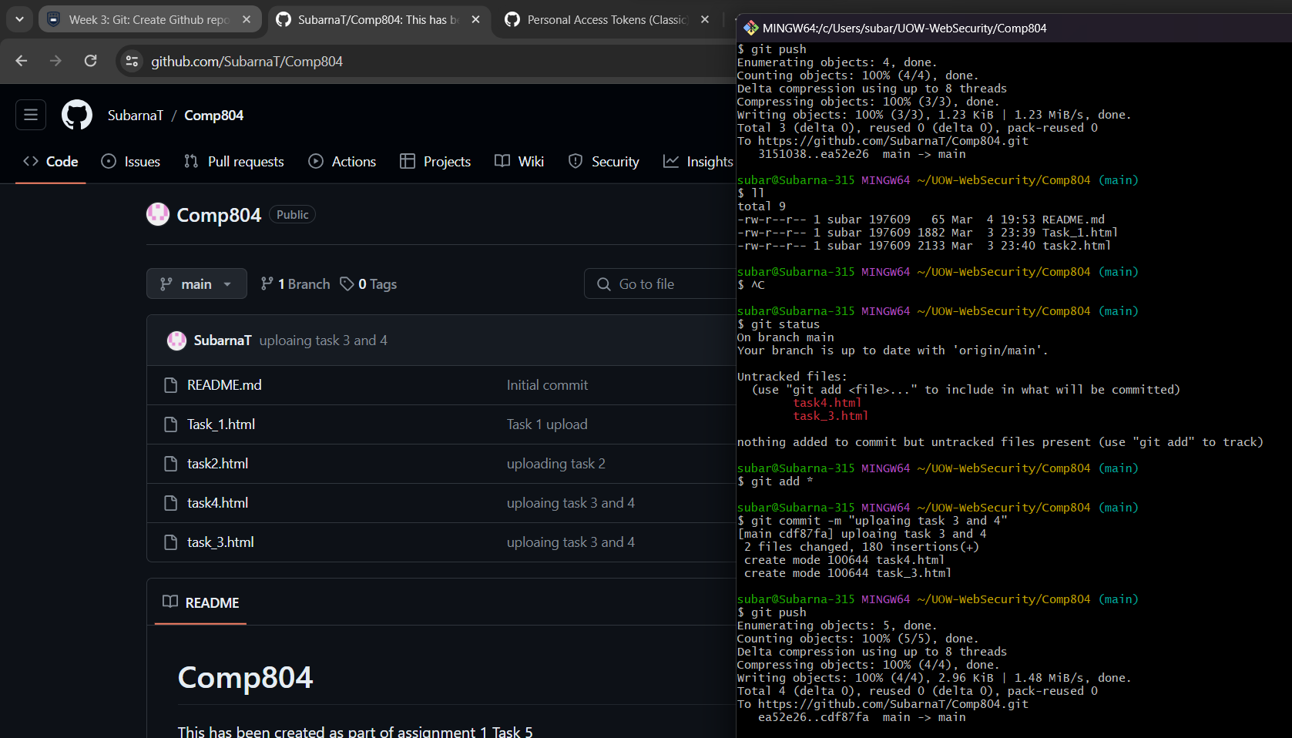

**Uploading the single file containing all code from task 1-4**

This is the hyperlink for git repository containing all file : [Git account of Subarna](https://github.com/SubarnaT/Comp804)